Title
Subtitle
First Author, Institution, email@email.org
SecondAuthor, Institution, email@email.org
Third Author, Institution, email@email.org

Overview
Text

Methods and Data
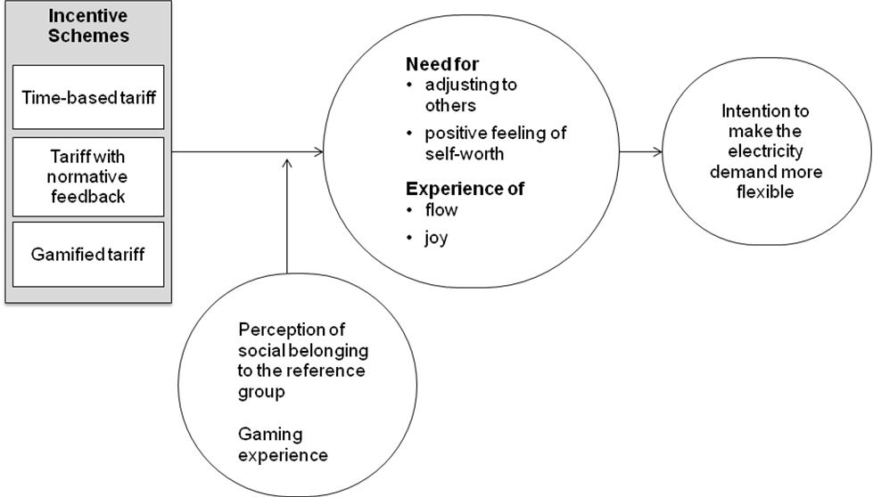
Fig. 1: Figure title
Text

Results
Text

Conclusions
Text

References
Gamma, K. (2016), Behavioral and Attitudinal Customer Loyalty in the Power Sector – An Explorative Investigation of the Effectiveness of Reward Programs, Zeitschrift für Energiewirtschaft 40(4), 211-232, doi: 10.1007/s12398-016-0186-3.

